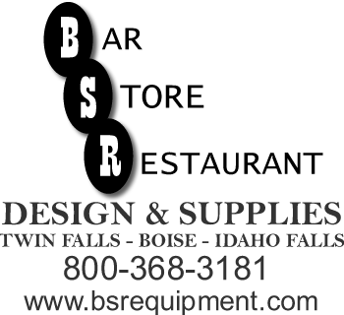
Idaho Falls Warehouse
240 1st Street
Idaho Falls , ID 83401
(208)-528-6233
(208)-529-4498 FAX
www.bsrequipment.com

FAX SHEET

DATE:
COMPANY:

Attn:

From:

Number of Pages to Follow:

Comments:

