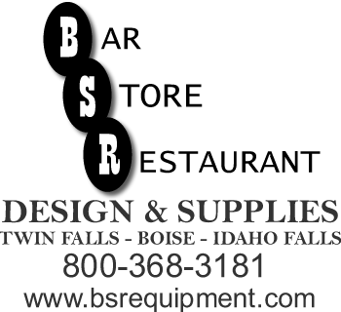
Design Center
3880 S. Development Ave.
BOISE , ID 83705
(208)-345-5793
(208)-319-1124 FAX
www.bsrequipment.com

FAX SHEET

DATE:
COMPANY:

Attn:

From:

Number of Pages to Follow:

Comments:

